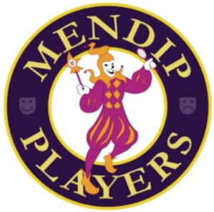

The Mendip Players – membership fees
Membership Types:

Adult (18+) £20
Youth (under 18 or still in full time education) £10
Family 1 (1 x adult + 1 x youth) £25
Family 2 (1 x adult + 2 x youths) £35
Family 3 (2 x adults + any number of youths) £45

Preferred payment by BACs or standing order
The Mendip Players
Sort code 60-05-12
Account number 17030072

If you would like to pay by cash or cheque, please contact themendipplayers@gmail.com or give directly to Brenda Apted, Membership Secretary, at any rehearsal.

